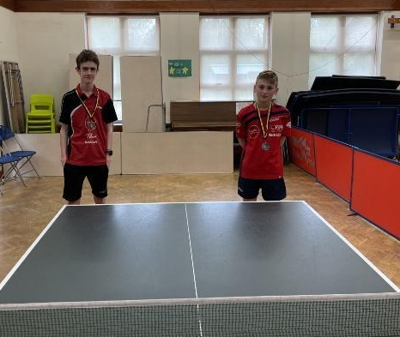
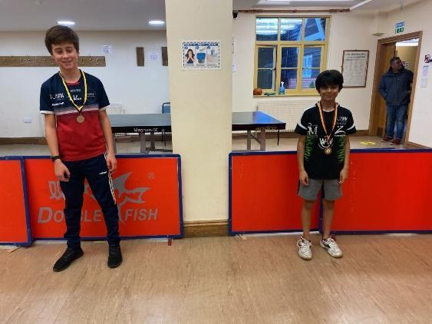

The tournament is included in the Computer Ranking Scheme
HORSHAM SPINNERS TABLE TENNIS CLUB
presents the
HORSHAM SPINNERS U12s, U13s, U14s, U15s, U18s & U19s 1 STAR
(as at 31/12/21)
Mixed Open Singles Table Tennis Tournament
Approved by Table Tennis England & Sussex County TTA
To be held at
SIX VILLAGES SPORTS CENTRE, LIME AVENUE, WESTERGATE, CHICHESTER, PO20 3UE.

ON SUNDAY 19th JUNE 2022
COMMENCING at 9.45am
CLOSING DATE for entries: Friday 10th June 2022
ORGANISING COMMITTEE:
Tournament Referee: Brett Holt (TO2, CU)
Tel: 07955 239389
e-mail: brettholtuk@gmail.com

Tournament Organiser: James Pettigrew (TO2, CU)

SCHEDULE:
Mixed U12s, U14s & U18s: 9.45am-1.45pm
Mixed U13s, U15s & U19s: 1.45-5.45pm
Entry form (PAGE 3 ONLY) must be emailed to the Brett Holt (use email above)
Payments to be made by bank transfer only.
Account name: HORSHAM SPINNERS TTC Sort code: 60-11-17 Account No: 19813082
Online Banking Reference: Player’s Full Name

TOURNAMENT INFORMATION:
1. Entries along with PAYMENT must be RECEIVED by email to Brett Holt by no later than 10th June 2022.
2. The Draw will be held on Thursday 16th June 2022.
3. If it becomes necessary to restrict entries, priority will be given in order of receipt. Late entries will only be accepted if there is still space in the appropriate event after the closing date.
4. Payment must be made by bank transfer by the closing date (or immediately for late entries).
Account Name: Horsham Spinners TTC, Account no.: 19813082, Sort code: 601117, online banking reference: Player’s Full Name

5. There will be a surcharge of £2 for those who enter and/or pay late or come for a scratch entry on the day.
6. There is ample free parking. There are changing rooms & shower facilities too.
7. Stag 3 star 40+ white balls will be used.
8. Play will take place on up to 8 Joola/Butterfly tables with Donic nets and posts and with Donic/Joola scoring machines.
9. Tables will be individually courted. Minimum ceiling height: 7m; Minimum Court Size: 9m X 5m.
10. Lighting is general and fluorescent lighting. Minimum Light intensity is 500 lux. Minimum height of lighting: 7m.
11. The venue has wooden sprung flooring.
12. There will be no admission charge.
13. Competitors will be informed by email that their entry has been received within 1 day of the entry being received and a confirmation email with more details will be sent out 2 days before the event. If you do not receive this, please get in touch with the referee.
14. No refunds are possible after the closing date under any circumstances.
15. The planned format is mainly groups of 4, but there may be some groups of 3 players. In all events, after the initial group stage, the top 2 players go into the main draw knock-out & the 3rd & 4th players go into the consolation draw knock-out. The format may be varied at the discretion of the Referee in light of entries received. Players looking for scratch entries should inform the Organiser in advance to secure their place. Turning up on the day, while allowed, is more risky.
16. There will be trophies or medals for the winners & runners-up in the main draw of each age group and bronze medals for 3rd placed players in categories with 7 or more entries.
17. There may be a STAG UK Trade stand at the tournament for players to purchase table tennis equipment.
18. The results from this tournament will qualify for computer ranking points.
19. Competitors may enter 1 or 2 events. If playing in 2 events, it must be one morning event & one afternoon event. See page 1 for schedule.

TOURNAMENT REGULATIONS:
1. TTE Regulations Part A (Regulated Competitions) and Part B (Tournament Regulations) apply to the tournament.
ITTF Regulations for International Competitions apply to the tournament except where otherwise specified in TTE Regulations Parts A or B, or in this form.
2. Every entrant must be affiliated as a Compete Member or be a member of another National Association in membership of the ITTF. It is not possible to acquire membership of Table Tennis England at the tournament.
3. Completion and submission of this entry form signifies agreement by the entrant to the conditions of the competition including any variations of ITTF regulations.
4. All matches shall be the best of five games up to 11. The final order in a Group shall be decided as per ITTF Regulation 3.7.5.
5. Competitors must report to Control on arrival and must not leave the hall without obtaining permission. Players absent when called upon to play are liable to be scratched.
6. The Organiser reserves the right to merge/cancel events if entries are low.
7. There will be no separate practice facilities, but competitors will be permitted to practice on match tables at the discretion of Control.
8. All competitors may be required to umpire one knockout match in each event entered after being knocked out.
9. Playing clothing shall consist of a shirt and shorts, trousers, leggings or skirt, or a one-part sports outfit, socks and playing shoes; a sports hijab may also be worn. Other garments shall not be worn during play except with the permission of the referee. ITTF 3.2.2.1 amended. The main colour of a shirt, shorts, trousers or skirt, other than sleeves and collar of a shirt, shall be clearly different from that of the ball in use. ITTF 3.2.2.2 amended.
10. Doping shall not take place either before or during play. Doping Control tests may take place.
11. No gluing up or boosting/tuning will be allowed.
12. No competitor or official shall engage in betting on players or matches.
13. Match results will be submitted for inclusion in the Table Tennis England computer ranking scheme.
14. Competitors must have been born in 2010 or later for the under 12s, 2009 or later for the under 13s, 2008 or later for the under 14s, 2007 or later for the under 15s, 2004 or later for the under 18s, or 2003 or later for the under 19s.

STAG HORSHAM SPINNERS U12s, U13s, U14s, U15s, U18s & U19s 1 STAR
Open Mixed Singles Table Tennis Tournament Sunday 19th June 2022
A separate entry form must be completed for each player and be emailed to Brett Holt: brettholtuk@gmail.com.
Entries to be received no later than Friday 10th June 2022. All entrants should ensure that they have read the regulations, which apply to this tournament.

PLEASE COMPLETE NEATLY IN BLOCK CAPITALS.

Mr/Miss: …........… Nationality:………………………………………………………………………………………………………………………...
Competitor's First & Last Names Only:.....................................................................................................................………
TTE Membership No:………………………..…………….……………..................Date of Birth:........../........../.......………………………...
Address: ..................................................................................................................……………………………………………………...
...............................................................................................................................Post Code:.……………………………………...
Home Tel. No.:............................................................ Mobile Phone No:...............................................……………………….
Email Address (Place one character in each box for clarity):

County of Affiliation: ……………………………..........................................................................…………………………………………….
National Association (if not affiliated to TTE): …………………………………………………………………………………………………………….
Name of Table Tennis Club:…………………………………………....................................................…………………………………………...

EVENT(S) | EVENT FEE | TICK ONE BOX ONLY | FEE
ELIGIBLE MORNING EVENT ONLY | £20.00 |  | £
ELIGIBLE AFTERNOON EVENT ONLY | £20.00 |  | £
BOTH MORNING AND AFTERNOON EVENTS | £25.00 |  | £
The fees shown include all TTE levies. |  |  | £
 | Total Fee Enclosed |  | £

Please make payment by bank transfer to:
Account name: HORSHAM SPINNERS TTC, Sort code: 60-11-17, Account No: 19813082, Your Reference: Player’s Full Name
IMPORTANT

Please read the Tournament regulations and conditions and unless otherwise agreed in advance do not enter unless you are prepared to play until the projected finish time of between 2pm (morning events) or 7pm (afternoon events).

I undertake to observe the regulations of the tournament, to abide by the decisions of the Referee, and to fulfil the schedule of play arranged for me unless prevented from doing so by circumstances beyond my control and accepted as such by the Referee.
Table Tennis England requires consent to the use of personal data in the administration of this competition, in accordance with the TTE Privacy Policy; the information will be shared where necessary with the organisers and event committee. For a player under 16 this consent must be given by a parent or guardian, who must also confirm agreement to the player’s participation in the competition. The TTE Privacy Policy is at https://www.tabletennisengland.co.uk/privacy-policy/

Date ………/………/………

Print Player Name ………………………………………………………………………………

If player is 16 or over:
Data Protection
I am the player named above and I consent to the use by TTE of my personal data in the administration of this competition.

Signed: .................................................................
If player is under 16:
Data Protection & Activity Consent
I have legal responsibility for the player named above and I consent to his/her participation in the competition, and to the use by TTE of his/her personal data in its administration.
Name: (Block Capitals) ......................................................
Relationship to player: .....................................................

Signed: .......................................................
If player is under 18:
Anti-Doping Acknowledgment
I have legal responsibility for the player named above and I confirm that I have read the TTE Anti-Doping
Regulations (Appendix P) and that I hereby acknowledge that the player is bound by these Regulations.
Name: (Block Capitals) ..............................................

Relationship to player: .............................................

Signed: ........................................................

