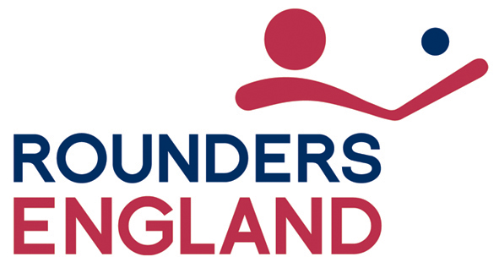

Equality Monitoring form

In accordance with its Equality Policy, Rounders England will provide equal opportunities to all employees and job applicants and will not discriminate either directly or indirectly on the grounds of race, colour, ethnic origin, nationality, national origin, sex, marital status, disability, sexual orientation, religion or age.

In order to enable Rounders England ensure compliance with its policy, a system of monitoring has been set up. We have only asked for your name so that monitoring can take place both at the shortlisting for interview stage and at the appointment stage. Once an appointment has been made, the data given on this form will be stored securely on computer in an anonymised format and the form will then be destroyed.

You may, of course, decide not to answer one or any of these questions but if you do respond, all information provided will be treated in confidence and will be used solely for the purpose of providing statistics for equal opportunities monitoring. The monitoring form does not form part of your application and will therefore be detached from it on receipt and stored separately. You can always mail this form separately if you wish.

Thank you for your assistance in completing this form.
Post title:
Where did you see the post advertised?
Gender: |  | Male |  |  | Female
Marital status: |  | Married |  |  | Single
 |  | Other (please specify)
Age band: |  | Under 25 |  |  | 25 – 34
 |  | 34 – 44 |  |  | 45 – 54
 |  | Over 55
Disabilities : Do you consider yourself to have a disability?
Yes No

If you have indicated yes, please mark all the boxes that apply to you:
Visual impairment Hearing impairment
Physical impairment Learning disability/difficulty
Other
(please specify) ………………………………………………………………..

Sexual orientation: |  | Heterosexual |  |  | Lesbian
 |  | Gay |  |  | Transsexual
 |  | Bisexual |  |  | Prefer not to say
Ethnic Origin: Please indicate the relevant category for you from A to E shown in the lists below and select your ethnic background by marking the appropriate box

A White  British  English  Scottish  Welsh  Other, please specify  ……………………………………...………  Irish  Any other White background, please specify  …………………………………….  C Asian, Asian British, Asian English, Asian Scottish, Asian Welsh, or Asian Irish  - Indian  - Pakistani  - Bangladeshi  - Any other Asian background, please specify …………………………………….  E Chinese, Chinese British, Chinese English, Chinese Scottish, Chinese Welsh, or Chinese Irish  Chinese  Any other background, please specify  ……………………………………………... |  |  |  | B Mixed, Mixed British, Mixed English, Mixed Scottish, Mixed Welsh, Mixed Irish  White and Black Caribbean  White and Black African  White and Asian  Any other Mixed background, please specify …………………………………..  D Black, Black British, Black English, Black Scottish, Black Welsh, or Black Irish  Caribbean  African  Any other Black background, please specify …………………………………..  F  Not declared

For the purposes of compliance with the Data Protection Act 1998, I hereby confirm that by completing this form I give my consent to Rounders England processing the data supplied on this form for the purpose of equal opportunities monitoring.

Signed: |  | Date

