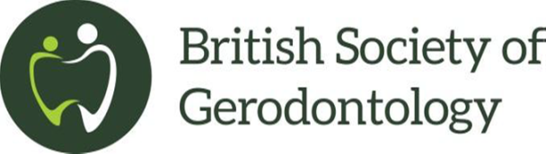

Registered charity: 1118671
www.gerodontology.com

History of The British Society of Gerodontology (BSG)

BSG was formed in the late 1980s as The Gerodontic Study Group (GSG) by Professor Emeritus Robin Heath. In these early stages, Robin formed a steering group of Bob Yemm, Tony Newton, Janice Fiske and Denise Mattin and it started from there. Other leading dentists dedicated to older people’s dentistry soon became involved. The aim was to forward learning, teaching and research in the field of Gerodontology
Robin was Head of Prosthetic Dentistry at The Royal London Hospital Medical College, and had established an innovative MSc in Gerodontics, which attracted many postgraduate students from every branch of dentistry, both within the UK and oversees. Publication of the research undertaken as part of this Masters degree course, contributed significantly to the development of Gerodontology. Robin became inaugural President of the society in 1990, and the first editor of Gerodontology, ‘the international journal of dental geriatrics’. The society flourished and developed as a specialist society
At the AGM on 6th December 1996, a name change was agreed and the GSG became The British Society of Gerodontology (BSG)
In 2001, with an aim to increase DCP membership and involvement, BSG welcomed its first DCP, Hilary Maynard, to the Executive Committee
In April 2007, charitable status was awarded
In 2014, a new website was launched along with a new logo
In 2016, our President Elect is Rosalyn Davies, a registered DCP and Service Manager
So what will the future look like as we progress over the next twenty-five years? Having been a BSG member since its beginning, I am truly delighted and honoured to be the 26th President. My view for the future would be to develop closer collaboration with our UK sibling society, The British Society of Disability and Oral Health (BSDH): for BSG and BSDH to work towards synergy for the advancement of Special Care Dentistry for Older People, would be a worthy silver anniversary celebration

Heather Lloyd
26th President of The British Society of Gerodontology
June 2016

PAST PRESIDENTS

1990-1991 Professor Robin Heath
1991-1992 Professor Alan Harrison
1992-1993 Arnold Franks
1993-1994 Professor Frazer McCord
1994-1995 Jean Kinsey
1995-1996 Professor Angus Walls
1996-1997 Janice Fiske
1997-1998 Peter Frost
1998-1999 Professor Robin Basker
1999-2000 Jim Newton
2000-2001 John Collis
2001-2002 Denise Mattin
2002-2003 Heather Frenkel
2003-2004 David Davis
2004-2005 Francis Burke
2005-2006 Janet Griffiths
2006-2007 Debbie Lewis
2007-2008 Professor Paul Wright
2008-2009 Nicola Pearson
2009-2010 David Russell
2010-2011 Vicki Jones
2011-2012 Tim Friel
2012-2013 Barbara Hylton
2013-2014 Mark Taylor
2014-2015 Geraldine Russell
2015-2016 Heather Lloyd

